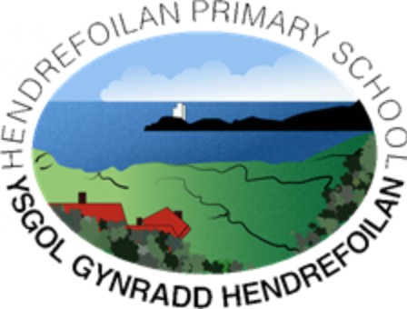

**“*Learn, have fun and reach for the stars”***

Super starter

Mega middle

Fabulous finish

Enquiry Questions

Local to Global

Outdoor Learning

Enrichment opportunities

Pupil Voice

Epic Plan topic

Inference picture

What do you see?

How do you feel?

What more do you want to know?

Pupil voice for missions

Dress as a great leader for year 3 (prepare a speech as the leader)

Visit from a local community leader / charity worker.

Nspcc / rights of a child

What is a leader?

What makes a good leader?

Who do you think is a leader? And why?

What differences to the world and society have been made by these leaders?

Visit from a local community leader / charity worker.

Year 3 & 4 role play debate (would you rather)

Dress up and become a great leader for a day.

EPIC planning

Revisit learning tree to add more ideas and evaluate enquiry ideas that have been addressed.

Children choose own items from home learning

Choose a known person to create a factfile on.

Share fortnightly ideas for missions 2 pupil voice/ 2 teacher led.

From Local heroes (Aneurin Bevan) to global leaders (Barak Obama)

Looking at great leaders across the world through history.

Great leaders

Outdoor challenges – choosing roles, developing skills

Mathematic activities

Outdoor – Tuesdays in Coed Cadno



**“*Learn, have fun and reach for the stars”***



Narratives –

Discussion text – pie corbett

Guided Reading - Carousel

5 minute presentations.

Year 3 & 4 role play debate (would you rather)

Dress up day as a leader

Language, Literacy & Communication

Area and Perimeter

Money

Line graphs

Fractions

Mathematics & Numeracy

Electricity

Logging into hwb, saving and sharing work independently

Using powerpoint, J2e, adobe spark

Internet Safety

Coding

Science & Technology

Art – Joseff Herman Paint

Observational drawing

D & T –

Tbc

St David’s day performance

Music – Charanga, garage band

Drama – Role play debate (year 3 & 4)

Becoming a great leader for the day.

Cooking – Making pizza and planning toppings with fraction.

Expressive Arts

5 pillars of Islam

Great leaders

Planning a blue print for a new hospital (liked to Aneurin Bevan)

Chineese new year

Dydd Santes Dwynwen

Humanities

P4C – importance of sleep and what is love

Mindfulness

Gymnastics / dance

Health & Wellbeing