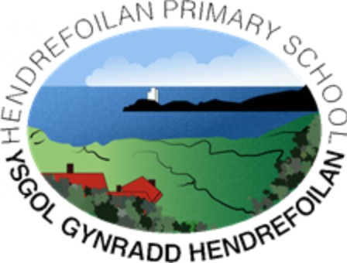

**“*Learn, have fun and reach for the stars”***

Super starter

Mega middle

Fabulous finish

Enquiry Questions

Local to Global

Outdoor Learning

Enrichment opportunities

Pupil Voice

EPIC knowledge tree

Inference picture – question what do you see, how do you feel and what more do you want to know?

Pupil voice for missions

Great Leader Day - Dress up as your chosen ‘Great Leader’ – prepare for ‘hot seating activity’ from Year 4

Visit from Local Community Leader – Charity worker – NSPCC Rights of the Child

EPIC questions on Planning Tree –

What is a leader?

What makes a great leader? Characteristics?

Who do you see as a leader and why?

Who do you know in your life that is a leader?

What differences have been made to the world and society by each leader?

Local visit from NSPCC Charity

Y3 and Y4 role play debate

Dress up and become a great leader for a day

EPIC Planning Trees – take leaves off when question is answered – put in polly pocket

Revisit Planning tree half way through topic to add more of the children’s enquiries on post its

Celebrate and acknowledge when and who’s question have been find out/answered

Children to choose their way of recording and creating in their home learning

Children to choose from accessible resources and mediums when making their ‘Great Leader’ creations

From Local heroes (Aneurin Bevan) to global icons (Rosa Parks)

Great leaders in the past and future from all across the world – following children’s EPIC

Great Leaders

Focus tasks and missions with whole class and groups

Tuesday afternoons in Coed Cadno

Cross curricular

Mathematics



**“*Learn, have fun and reach for the stars”***



Oracy - Y3 and Y4 role play debate in the hall with props – Would you rather – building on from ones done in class

Narrative

Persuasion – PIE CORBETT -

Information text - Biography

Poetry –

Handwriting – continuous cursive

Guided Reading – English and Welsh

5 Minute Presentations – choice

Daily newsround

Language, Literacy & Communication

Addition, Subtraction, multiplication and division

Measuring (to the nearest cm and mm)

Money – making pounds and pence and adding amounts

Telling the time – analogue, digital and 5 minute intervals

Passing of time

Problem solving

Mathematics & Numeracy

Light and sound

Logging into HWB independently

Using Powerpoint

Internet Safety

Adobe Spark

Science & Technology

Art – Collage of chosen ‘Great Leader’

Joseff Herman

Outdoor mud painting

D & T – tbc

Music – Charanga

Drama – Role play debate (year 3 and 4)

Expressive Arts

Celebrations, Ramadan, Wesak

Great Leaders

Alexander the Great/Boudicca – battlefields

Chinese New Year

Dydd Santes Dwynwyn

Humanities

PHSE- Going for goals and staying clean

P4C

Gymnastics, dance, hockey

Mindfulness – every day at 1pm

Health & Wellbeing