Hello,

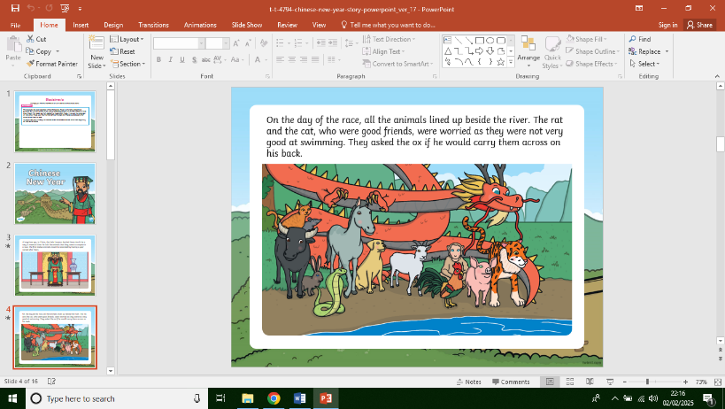In our Literacy sessions this week we looked at the new phonic sounds y and z. We learned the actions from the scheme and the set of rhymes to form the letters when writing. This week was y for yoyo, where you had to pretend to be playing with a yoyo. Z was for zip and you had to pretend to zip up a jacket. We also listened to the story of Chinese New Year and the race of the animals of the zodiac. We did some free writing about the story thinking about what our favourite animal was and what they were like in the story. In an attempt to develop independence in writing, I am encouraging all children to try sounding out and writing some words by themselves. The adult repeats their word choices slowly, emphasising each sound. This is giving the opportunity to repeat and re-enforce formation rhymes.

E.G. I liked the …….. best.

………. was …………

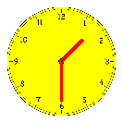In our maths we looked at adding 2 sets of numbers together sing Dienes apparatus to help. We also started to learn to tell the time on an analogue clock, starting with o’clock.

In our Welsh session we carried on learning to say who we are, (…. dw i.) in answer to the question- Pwy wyt ti? Mrs Bowen filmed us speaking. We also said who a friend was by saying – Dyma … (This is …)

In gymnastics we used the holds we have learned so far and together with different ways of travelling, put together a simple 3 hold 2 travel routines. We then watched each other and started to learn how to pick out good aspects and areas that could be improved in someone else’s routine.

Finally this week we carried on our reading with the blue group, who have all taken their first books to share at home. In order to re-enforce and help build memory recognition of words, especially tricky words, sharing the book at least 3 times with an adult at home (over 10 days) is best to help the children progress as much as possible.



[This Photo](http://divinapastorabarco.blogspot.com/2012_06_01_archive.html) by Unknown Author is licensed under [CC BY-NC-ND](https://creativecommons.org/licenses/by-nc-nd/3.0/)

Have a lovely weekend and will see you all next week.

Miss Thomas, Mr Birtwistle, Mrs Bowen & Mrs Davies.